- Experiment 3: TurtleSim Programming, Publisher, Subscriber, Services, Actions

Recap:

Setup for launch files:
- Create a new package
- Create a launch/ folder at the root of the package.
- Configure CMakeLists.txt to install files from this launch/ folder.
- Create any number of files you want inside the launch/ folder, ending with .launch.py.
Run a launch file:
- use “colcon build” to install the file.
- source your environment
- launch file with “ros2 launch <package> <name_of_the_file>
First try to design the application by yourself. Don’t write code! Just take a piece of paper and make the design. What nodes should you create? How do the nodes communicate between each other? Which functionality should you add, and where to put them? Etc.
- Directly start on your own (Use the template to start with)
- Work step by step on each functionality/communication.

Client – Server Nodes

Execute in Terminal #1
mkdir -p ~/ros2_ws/src
cd ~/ros2_ws/src
ros2 pkg create --build-type ament_python my_package --dependencies rclpy
ros2 interface show example_interfaces/srv/AddTwoInts

Execute in Terminal #1
cd
cd ros2_ws/src/my_package/my_package
touch add_two_ints_server.py
chmod +x add_two_ints_server.py

Edit add_two_ints_server.py in visual studio editor

#!/usr/bin/env python3
import rclpy
from rclpy.node import Node
from example_interfaces.srv import AddTwoInts

class AddTwoIntsServerNode(Node):
def __init__(self):
super().__init__("add_two_ints_server")
self.server_ = self.create_service(AddTwoInts, "add_two_ints", self.callback_add_two_ints)
self.get_logger().info("Add two ints server has been started")

def callback_add_two_ints(self, request, response):
response.sum = request.a + request.b
self.get_logger().info(str(request.a)+ " + " + str(request.b) + " = " + str(response.sum))
return response

def main(args=None):
rclpy.init(args=args)
node = AddTwoIntsServerNode()
rclpy.spin(node)
rclpy.shutdown()

if __name__ == "__main__":
main()

Add executable name in setup.py
entry_points={
'console_scripts': [
'sample = my_package.sample:main',
'robot_publisher = my_package.robot_publisher:main',
'robot_subscriber = my_package.robot_subscriber:main',
'add_two_ints_server = my_package.add_two_ints_server:main'
],

Execute in Terminal #1
cd
cd ros2_ws
colcon build

Execute in Terminal #2
source ~/ros2_ws/install/setup.bash
ros2 run my_package add_two_ints_server

Execute in Terminal #3
ros2 service call /add_two_ints example_interfaces/srv/AddTwoInts "{a: 3, b: 4}"

Ctrl + C in all terminal windows.
Execute in Terminal #1
cd
cd ros2_ws/src/my_package/my_package/
touch add_two_ints_client.py
chmod +x add_two_ints_client.py

Edit add_two_ints_client.py using visual studio editor

#!/usr/bin/env python3
import rclpy
from rclpy.node import Node
from example_interfaces.srv import AddTwoInts
from functools import partial

class AddTwoIntClientNode(Node):
def __init__(self):
super().__init__("add_two_ints_client")
self.call_add_two_int_server(6, 7)

def call_add_two_int_server(self, a, b):
client = self.create_client(AddTwoInts, "add_two_ints")
while not client.wait_for_service(1.0):
self.get_logger().warn("Waiting for Server Add Two Ints")
request = AddTwoInts.Request()
request.a = a
request.b = b
future = client.call_async(request)
future.add_done_callback(
partial(self.callback_call_two_ints, a=a, b=b))

def callback_call_two_ints(self, future, a, b):
try:
response = future.result()
self.get_logger().info(str(a) + " + " + str(b) + " = " + str(response.sum))

except Exception as e:
self.get_logger().error("Service call failed %r" % (e,))

def main(args=None):
rclpy.init(args=args)
node = AddTwoIntClientNode()
rclpy.spin(node)
rclpy.shutdown()

if __name__ == "__main__":
main()

Add executable name in setup.py
entry_points={
'sample = my_package.sample:main',
'robot_publisher = my_package.robot_publisher:main',
'robot_subscriber = my_package.robot_subscriber:main',
'add_two_ints_server = my_package.add_two_ints_server:main',
'add_two_ints_client = my_package.add_two_ints_client:main'
],

Execute in Terminal #1
cd
cd ros2_ws
colcon build

Execute in Terminal #2
ros2 run my_package add_two_ints_server

Execute in Terminal #3
ros2 run my_package add_two_ints_client

Execute in Terminal #4
ros2 node list

Execute in Terminal #5
ros2 service list
rqt
plugins→services→service caller
service - /add_two_ints
Enter the values under Expression for a and b
Click call
Response is viewed in the second window

Exercise 1: Create a service-client operation to reset the counter value in the number_counter nodes.

The node “number_publisher” publishes a number on the /”number” topic.
The node “number_counter” gets the number, adds it to a counter, and publishes the counter on the “/number_count” topic.
Add the following ros2 services

Add a functionality to reset the counter to zero:
- Create a service server inside the “number_counter” node.
- Service name: “/reset_counter”
- Service type: example_interfaces/srv/SetBool. Use “ros2 interface show” to discover what’s inside!
- When the server is called, you check the boolean data from the request. If true, you set the counter variable to 0.
We will then call the service directly from the command line. You can also decide - for more practice - to create your own custom node to call this “/reset_counter” service.
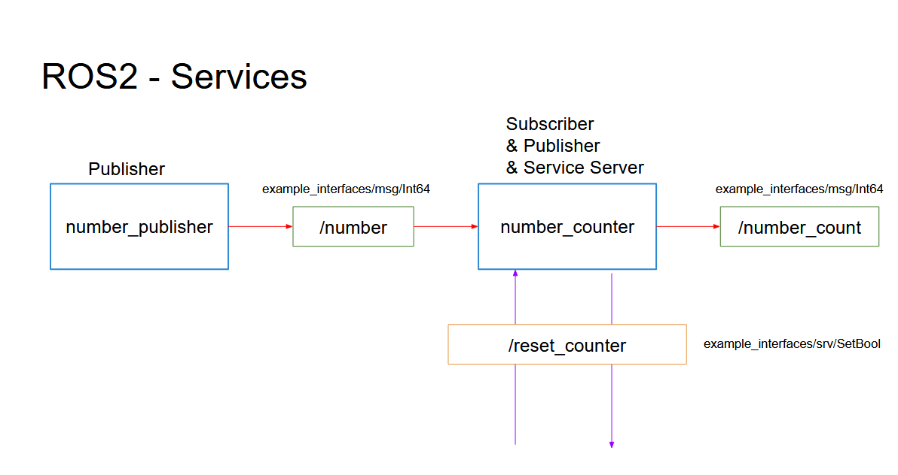

Add a functionality to reset the counter to zero:
- Create a service server inside the “number_counter” node.
- Service name: “/reset_counter”
- Service type: example_interfaces/srv/SetBool. Use “ros2 interface show” to discover what’s inside!
- When the server is called, you check the boolean data from the request. If true, you set the counter variable to 0.
We will then call the service directly from the command line. You can also decide - for more practice - to create your own custom node to call this “/reset_counter” service.

TurtleSim Programming

Execute in Terminal #1
ros2 run turtlesim turtlesim_node
Execute in Terminal #2
ros2 run turtlesim turtle_teleop_key
Execute in Terminal #3
ros2 service list
ros2 service type /clear
ros2 interface show std_srvs/srv/Empty
ros2 service call /clear std_srvs/srv/Empty
ros2 service type /spawn
ros2 interface show turtlesim/srv/Spawn
ros2 service call /spawn turtlesim/srv/Spawn
ros2 service call /spawn turtlesim/srv/Spawn "{x: 5.0, y: 5.0, theta: 0.0, name: "my_turtle"}"

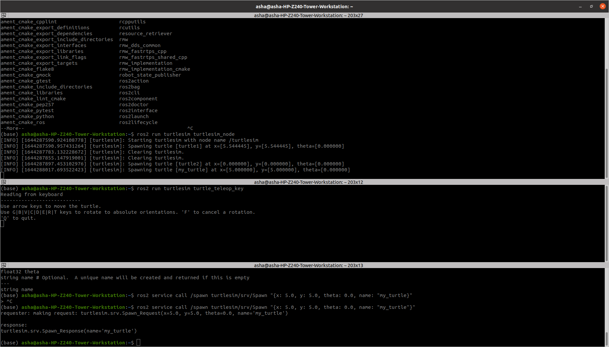

ROS2 interfaces:

https://github.com/ros2/example_interfaces
https://github.com/ros2/common_interfaces

You will use 3 nodes:
- The turtlesim_node from the turtlesim package
- A custom node to control the turtle (named “turtle1”) which is already existing in the turtlesim_node. This node can be called turtle_controller.
- A custom node to spawn turtles on the window. This node can be called turtle_spawner.
Execute in Terminal #1
cd ~/ros2_ws/src/my_package/my_package
Execute in Terminal #2
touch turtle_controller.py
chmod + turtle_controller.py

Open src with Visual Studio Application
Enter the code in turtle_controller.py

#!/usr/bin/env python3
import rclpy
from rclpy.node import Node
from turtlesim.msg import Pose
from geometry_msgs.msg import Twist
import math

class TurtleControllerNode(Node):
def __init__(self):
super().__init__("turtle_controller")
self.target_x = 8.0
self.target_y = 4.0
self.pose_ = None
self.cmd_vel_publisher_ = self.create_publisher(Twist, "turtle1/cmd_vel", 10)
self.pose_subscriber_ = self.create_subscription(Pose, "turtle1/pose", self.callback_turtle_pose, 10)
self.control_loop_timer_ = self.create_timer(0.01, self.control_loop)

def callback_turtle_pose(self,msg):
self.pose_ = msg

def control_loop(self):
if self.pose_ == None:
return
dist_x = self.target_x - self.pose_.x
dist_y = self.target_y - self.pose_.y
distance = math.sqrt(dist_x * dist_x + dist_y * dist_y)
msg = Twist()
if distance > 0.5:
msg.linear.x = distance
goal_theta = math.atan2(dist_y, dist_x)
diff = goal_theta - self.pose_.theta

if diff > math.pi:
diff -= 2*math.pi
elif diff < -math.pi:
diff += 2*math.pi

msg.angular.z = diff
else:
msg.linear.x = 0.0
msg.angular.z = 0.0

self.cmd_vel_publisher_.publish(msg)

def main(args=None):
rclpy.init(args=args)
node = TurtleControllerNode()
rclpy.spin(node)
rclpy.shutdown()

if __name__ == "__main__":
main()

Modify entry_points setup.py as

entry_points={
'console_scripts': [
'sample = my_package.sample:main',
'robot_publisher = my_package.robot_publisher:main',
'robot_subscriber = my_package.robot_subscriber:main',
'turtlesim_controller = my_package.turtle_controller:main'
],
},
)

Modify he package.xml as

<depend>rclpy</depend>
<depend>example_interfaces</depend>
<depend>my_robot_interface</depend>
<depend>turtlesim</depend>

Execute in Terminal #1
ros2 run turtlesim turtlesim_node

Execute in Terminal #2

colcon build --packages-select my_package --symlink-install

Execute in Terminal #3

ros2 run my_package turtlesim_controller

Execute in Terminal #4
ros2 service list
ros2 service type /spawn
ros2 interface show turtlesim/srv/Spawn

